CUSTOMER CHURN ANALYSIS IN EUROPEAN

Abstract
Customer churn is one of the most significant challenges faced by financial institutions. This study analyses customer churn behaviour using a European banking dataset containing demographic, financial, and customer engagement attributes. The objective is to identify key churn drivers, evaluate customer risk segments, and provide business recommendations through data analytics and machine learning. The study combines customer segmentation, exploratory data analysis, churn distribution assessment, revenue risk estimation, and predictive modelling. Results indicate that age, balance, customer activity, and product ownership significantly influence churn behaviour.

1. Introduction
Customer retention is a critical success factor in the banking industry. Losing existing customers can result in reduced profitability, lower customer lifetime value, and increased acquisition costs.
This research aims to:
- Understand customer churn behaviour
- Identify high-risk customer segments
- Evaluate financial impact of churn
- Develop a predictive machine learning framework

2. Dataset Overview
Dataset Characteristics
The dataset contains 10,000 customer records and includes:
- Customer Id
- Credit Score
- Geography
- Gender
- Age
- Tenure
- Balance
- Num Of Products
- Has Cr Card
- Is Active Member
- Estimated Salary
- Exited
Target Variable
Exited:
- 0 = Customer Retained
- 1 = Customer Churned
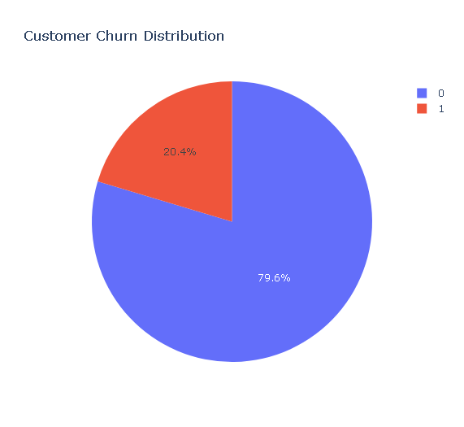

3. Data Preparation
The following preprocessing steps were performed:
- Removal of non-analytical fields
- Feature engineering
- Customer segmentation
- Data validation
- Categorical encoding
- Churn label verification
Created Segments:
- AgeGroup
- Balance Group
- Salary Group
- Credit Score Band
- Tenure Group

4. Customer Segmentation Analysis
Geographic Segmentation
Countries analysed:
- France
- Germany
- Spain
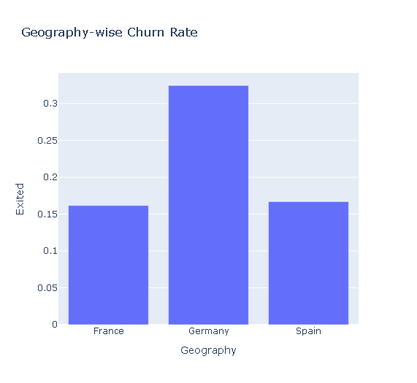Age Segmentation
Age Categories:
- Less than 30
- 30–45
- 46–60
- Above 60
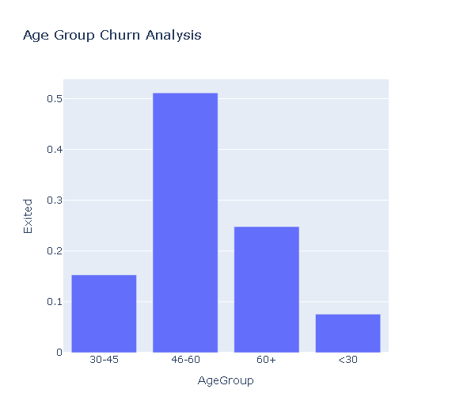Credit Score Segmentation
Categories:
- Low
- Medium
- High
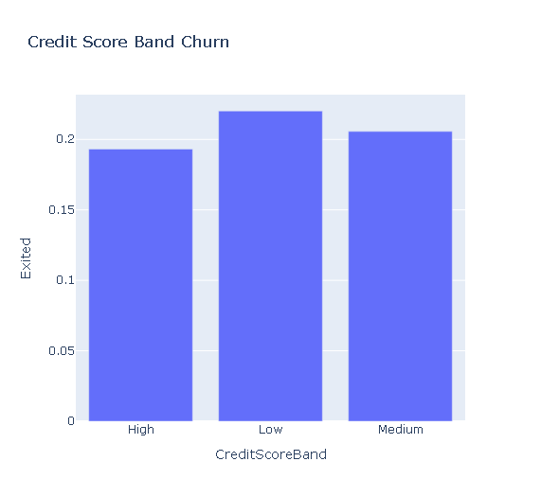
5. Churn Distribution Analysis
The overall churn rate was evaluated across all customer segments.
Key findings:
- Churn is concentrated among older customers.
- Inactive members exhibit significantly higher churn.
- Customers with fewer products demonstrate elevated churn risk.

6. Demographic Analysis
Gender Analysis
Results indicate that demographic characteristics alone are insufficient to explain churn behaviour. Customer activity and financial attributes contribute more strongly.
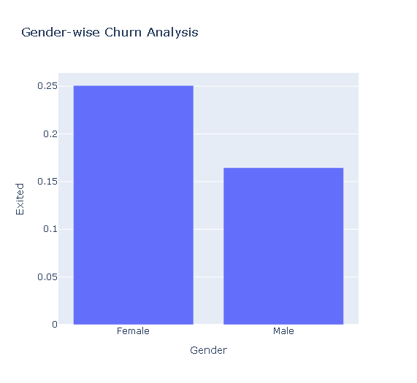

7. Financial Behaviour Analysis
Balance Analysis
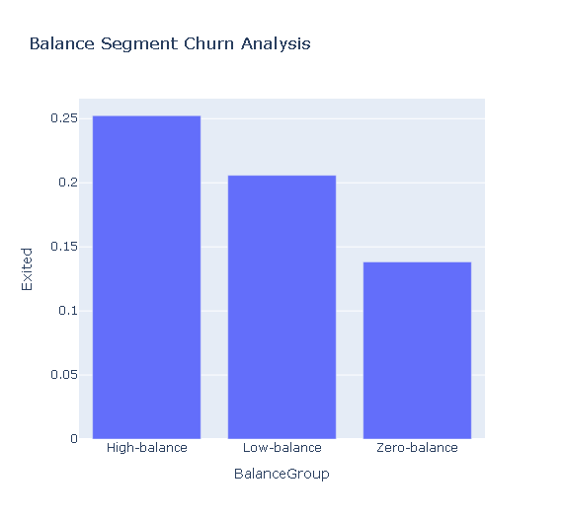
Key observations:
- High-balance customers contribute substantial revenue risk.
- Zero-balance customers demonstrate elevated churn probability.
Salary vs Balance Analysis
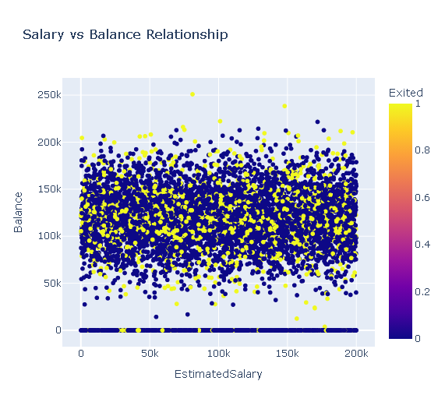Results suggest that salary and account balance are not strongly correlated.

8. Revenue Risk Assessment
Revenue risk was estimated using balances associated with churned customers.
The analysis identified high-value customers as a critical business segment requiring proactive retention strategies.

9. Machine Learning Model
Model Used
Random Forest Classifier
Purpose
To identify important predictors of customer churn and support early intervention strategies.

Feature Importance Analysis
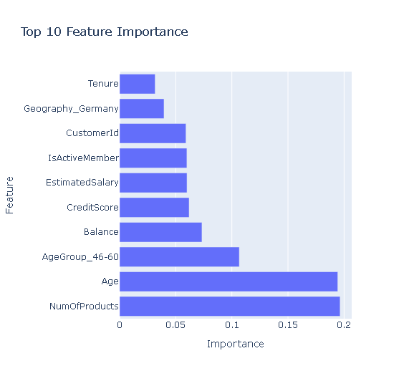
Important predictors include:
- Age
- Balance
- Is Active Member
- Credit Score
- Num Of Products

10. Key Findings
- Customer inactivity is strongly associated with churn.
- Older customer groups show higher churn probability.
- High-balance customers contribute significant revenue risk.
- Geography influences customer retention behaviour.
- Product ownership impacts churn likelihood.
- Age and balance are major churn predictors.
- Random Forest effectively identifies churn drivers.

11. Business Recommendations
- Develop retention campaigns for high-risk customers.
- Increase engagement among inactive members.
- Monitor high-value customers proactively.
- Implement predictive churn monitoring.
- Expand personalized banking services.

12. Conclusion
This research demonstrates the effectiveness of combining customer segmentation, business analytics, and machine learning to understand churn behaviour in the banking sector. The findings provide actionable insights for improving customer retention, reducing revenue loss, and supporting data-driven decision-making.

